Solution to Final Exam Paper A

1. [8 Marks] For a motion with constant acceleration, the equation of average velocity is . It is not valid for the case when the acceleration , where *A* and *B* are constants. Prove that for this case , rather than .

+2

【Solution】:

The definition of average velocity is , so we have to find the position as a function of time. Because we are given the acceleration as a function of time, we first find the velocity by integrating 





We assume when *t*=0, , then  , So

+2



We find the position by integrating 





We assume when *t*=0, , then  , So

+2



Thus, the average velocity is



+2

However,



which is not the average velocity.

2. [8 Marks] At time *t*=0, a 2150 kg rocket in outer space fires an engine that exerts an increasing force on it in the +x direction. This force obeys the equation *F*x=*At*2, where *t* is time, and has a magnitude of 781.25 N when *t*=1.25 s. (a) Find the value of the constant *A*, including its unit. (b) What impulse does the engine exert on the rocket during the 1.50 s interval starting 2.00 s after the engine is fired? (c) By how much does the rocket’s velocity change during this interval?

【Solution】:

1. Substitute *F*x=781.25 *N* when *t*=1.25 *s* into the force equation, we have

+2



+2

1. The impulse

+2



+2

1. 

The *x* component of the velocity of the rocket increases by 2.70 m/s.

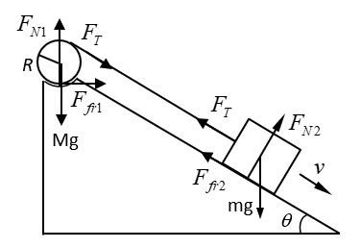3. [10 Marks] A cord connected at one end to a block of mass *m*=3.0 kg which can slide on an inclined plane has its other end wrapped around a cylinder (radius *R* and mass *M*=30 kg) resting in a depression at the top of the plane as shown. The inclined plane makes an angle with horizontal. Determine (a) the tension force *F*T, friction forces *F*fr1 and *F*fr2. (b) the speed ** of the block after it has traveled a distance *D*=1.80 m along the plane starting from rest. Assume the coefficient of friction between all surfaces is μ=0.035.

【Solution】:

(a) Assume the mass *m* moves down the inclined plane at acceleration , and the cylinder has an angular acceleration . From the force diagram we see that





+4







Solve above five equations for *F*T



Thus

+2





(b) When the block moves a distance *D*, the surface of the rotating cylinder will move a distance *D* through the depression. For the work-energy principle we have



or

+2





Therefore

0.79m/s

+2

4. [10 Marks] A uniform rod of length *L* and mass 2*m* rests on a smooth horizontal table. A point mass *m* moving horizontally at right angle to the rod with an initial velocity  collides with one end of the rod and sticks to it. Determine (a) the rotational inertia  about the axis passing through the center of mass after the collision, (b) the angular velocity *ω* of the system after the collision,(c) the position of the point on the rod which remains stationary immediately after the collision, and (d) the change in kinetic energy of the system as a whole as a result of the collision.

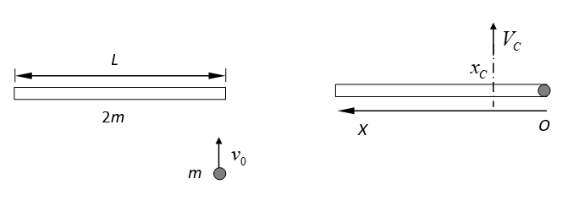

【Solution】:

Set an one dimensional coordinate system along the rod so that the origin of x axis is at the right end of the rod and the positive direction is to the left.

1. The position of the center of mass after collision locates at



The distance between the midpoint of the rod and the center of mass after collision is



According to the parallel axis theorem, the rotational inertial of rod about the axis passing through the center of mass is



The point mass will add a to the above value. So the total rotational inertial of the system about the axis passing through the center of mass after collision is

+3



1. During the collision no external forces act, so angular momentum of the system is conserved.



Solve the above equation, we get

+2



1. We assume the center of mass for the system after collision translationally moves at velocity *V*C. Since the linear momentum of the system is conserved, we have



So,



Consider the point on the rod remaining stationary immediately after the collision is located at *x.*

Because the linear velocity of any point to the right of the center of mass will be



Since ,



No points to the right of the center of mass will remain constant after the collision.

The linear velocity of any point to the left of the center of mass will be



Let 

We have

+3



So the point is a distance from the end to which the mass sticks.

1. The initial kinetic energy is 

and the final kinetic energy is



+2



Thus, the loss of kinetic energy is 

5. [8 Marks] (a) For what mass of molecule or particle is equal to 1.00 mm/s at 300 K? (b) If the particle is an ice crystal, how many molecules does it contain? The molar mass of water is 18.0 g/mol. (c) Calculate the diameter of the particle if it is a spherical piece of ice. Would it be visible to the human naked eye?

【Solution】:

+2

1. Since room mean square speed 

So

+2



+2

1. 
2. Because the volume of a sphere 

The diameter is

+2



which is too small to see.

6. [10 Marks] A cylinder contains oxygen at a pressure of 2.00 atm. The volume is 4.00 L and the temperature is 300 K. Assume that the oxygen may be treated as an ideal gas. The oxygen is carried through the following processes: (i) Heated at constant pressure from the initial state (State 1) to State 2, which has T=450K. (ii) Cooled at constant volume to 250K (State 3). (iii) Compressed at constant temperature to a volume of 4.00 L (State 4). (iv) Heated at constant volume to 300 K, which takes the system back to State 1. (a) Show these four processes in a PV-diagram, giving the numerical values of P and V in each of the four states. (b) Calculate the value of constant volume specific heat  and constant pressure specific heat  of oxygen by using the equipartition theorem of energy. (c) Calculate Q and W for each of the four processes. (d) Calculate the net work done by the oxygen. (e) What is the efficiency of this device as a heat engine? How does this compare to the efficiency of a Carnot engine operating between the same minimum temperature 250 K and maximum temperature 450 K?

【Solution】:

(a) 

, , 

, , 

+1

, , 

, , 

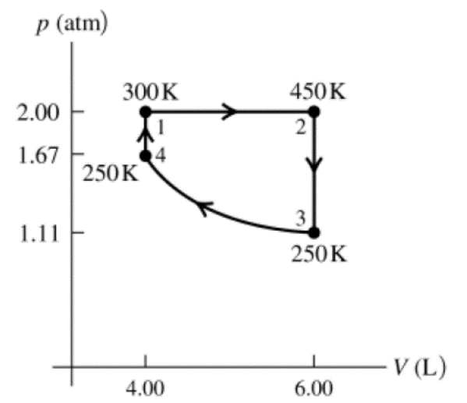

+1

(b) 



+1



(c)

+4

Process 1 to 2: constant pressure





Process 2 to 3: constant volume





Process 3 to 4: constant temperature





Process 4 to 1: constant volume





+1

(d) 

+1

(e) 

+1



7. [10 Marks] A certain brand of freezer is advertised to use 730 kW·h of energy per year. (a) Assuming the freezer operates for 5 hours each day, how much electrical power does it require while operating? (b) If the freezer keeps its interior storage at a temperature of -5.0 ℃ while the room temperature is 20.0 ℃, what is its theoretical maximum coefficient of performance? (c) What is the theoretical maximum amount of ice this freezer could make in an hour starting with water at 20.0 ℃? The specific heat of water and the latent heat for water changing phase to ice .

【Solution】:

(a) In one year the freezer operates a total time



The electrical power

+2



(b) Its theoretical maximum coefficient of performance

+2



+2

(c) Because 

In one hour the electricity does work



So, in one hour the freezer remove heat from the storage



+2

Since 

The amount of ice this freezer could make is

+2



8. [10 Marks] A 5.00-kg block is suspended from an ideal spring of negligible mass. When the block is pulled down 0.100 m below its equilibrium position and released, it vibrates with a period of 4.20 s. (a) What is its speed as it passes through the equilibrium position? (b) What is its acceleration when it is 0.05 m above the equilibrium position? (c) When it is moving upward, how much time is required for it to move from a point 0.050 m below its equilibrium position to a point 0.050 m above it?

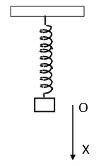

【Solution】:

Measure x from the equilibrium position of the block, where the gravity and spring force balance. Let +x be downward.

1. Amplitude , Period 

+2



As the block passes through the equilibrium position,

+2



(b) 

+2



(c) 

As  , so 

+2

The oscillation function is 

The block moves from  to 

The phase changes from to 



+2

9. [10 Marks] A transverse wave on a string has wave speed 8.00 m/s, amplitude 0.070 m, and wavelength 0.320 m. The wave travels in the negative x direction. At *t*=0 the end of the string (*x*=0) has its maximum upward displacement. (a) Find the frequency and period of the wave. (b) Write a wave function describing the wave. (c) Find the transverse displacement of a particle at x=0.360 m at time t=0.150 s.

【Solution】:

(a) 

+2

So 



+2

(b) For a wave travelling in the negative x direction, the wave function can be expressed as



Since at t=0 the end of the string (x=0) has its maximum upward displacement.

, So 

Therefore, the wave function is



+3

Or 

(c) at x=0.360 m and t=0.150 s

+3

The displacement of a particle



10. [8 Marks] A uniform film of TiO2 with thickness of 1036 nm and index of refraction 2.62 is spread uniformly over the surface of a glass plate of refractive index 1.52. Light of wavelength 520.0 nm falls at normal incidence onto the film from air. It is found that this TiO2 film does not cancel the reflected light properly. You want to increase the thickness of this film so that the reflected light cancels. What is the minimum thickness of TiO2 that you must add so the reflected light cancels as desired?

【Solution】:

There is a π phase change at the TiO2 surface but none at the glass surface, so there is  additional path difference for the light reflected from the surface of TiO2 and that of glass.

Assume the new thickness of TiO2 is *e.* The destructive interference condition for the path difference is

+2



Or

+2



Because the original thickness of TiO2 is 1036 nm, the new one should be greater than this.

So, take , which gives 

+2

+2

The minimum thickness to add is



11. [8 Marks] Jupiter is 5.93×108 km away from the earth orbit. You are asked to design a space telescope to resolve features on Jupiter that are 250 km apart. What minimum diameter of the telescope is required? Assume a wavelength of 500 nm.

【Solution】:

+2

The resolve features on Jupiter have an angular separation



+3

Since 

The diameter of the telescope

+3

